# Use Case: Animal Horror Zoo

Title: Choose your character

Actor: player 1

Scenario:

1: Player 1 starts the game.

2: Player 1 chooses to be the rabbit or the snake.

3: The game starts.

Title: Move your character

Actor: player 1

Scenario:

1: Both the snake and the rabbit spawns at a random location.

2: Player 1 is now presented with 4 movement options (up, down, left and right).

3: Player 1 chooses his move.

4: Player 1 is told where the snakes location is.

5: Player 1 moves until he is caught.

# Domain Model:

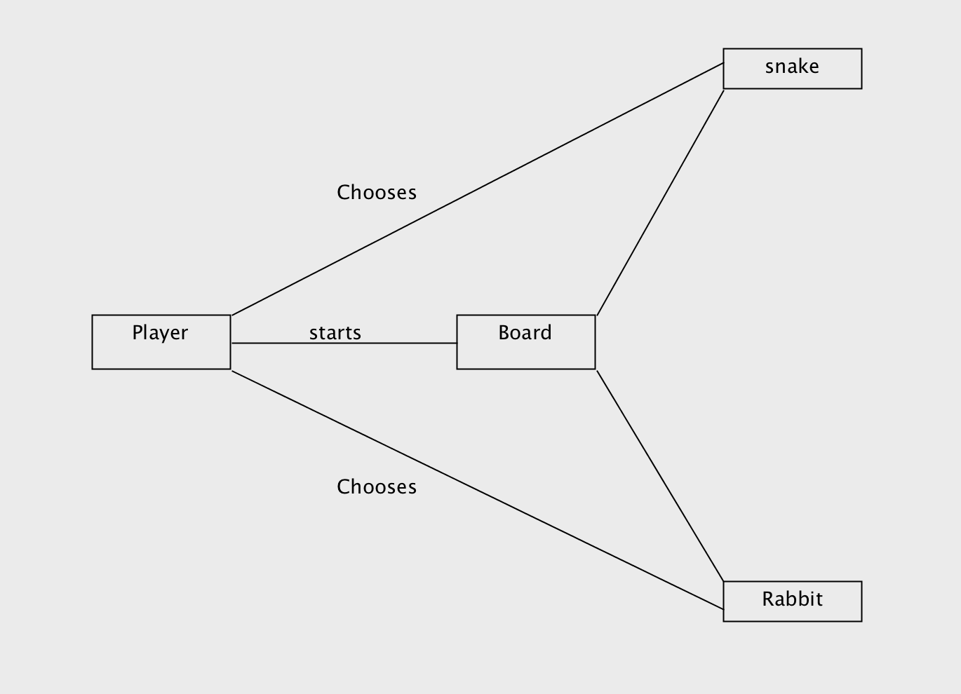

# Class Diagram

|  |
| --- |
| board |
| -Name: String “board”  -x: Int  -y: Int |
| + fight(); |

|  |
| --- |
| Rabbit |
| - Name: String “Rabbit”  - x: int  - y: int |
| + move right();  + move left();  + move up();  + move down();  + getLocation();  + printlocation();  + ask for mercy(); |

|  |
| --- |
| Snake |
| - Name: String “Snake”  - x: int  - y: int |
| + move right();  + move left();  + move up();  + move down();  + getLocation();  + printLocation();  + kill rabbit(): |